

**School of Information Technology**

Course : Diploma in Business Informatics

Subject : ITP282 - Enterprise Application Development & Project

AY / Sem : 2018 S2

**Lab Practical Test Revision**

**Question 1:**

**Refer to Lab 5b**

**Exercise 1:** Using Parameterised Query

To retrieve details (Name) using **ExecuteReader** based on input from user (Category ID)

**Exercise 3:** Updating Data

To update details (Name) using **ExecuteNonQuery**

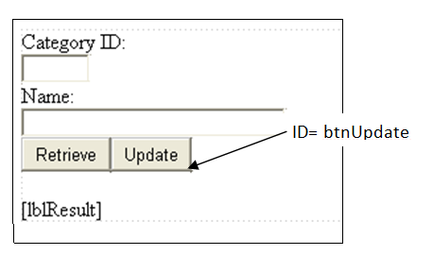

**Question 2:**

**Refer to Lab 5c**

**Exercise 1:** Data Binding

To bind drop down list with data from Database table (as shown in following figure).

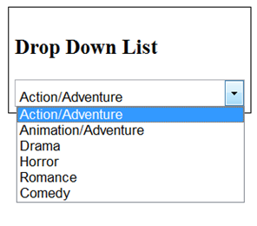

**Exercise 2:**  Grid View: Displaying data and customisation

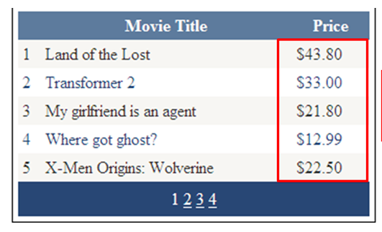

**========== End ==========**